

## INFORMATION TECHNOLOGY EDUCATION DEPARTMENT

**ITEI223**

(Advanced Programming)

MODULE

4

INTRODUCTION TO POINTERS

LABORATORY EXERCISE 4 - 01

**Simple Pointer**

NAME OF STUDENT Domingo, Julian_________________________ DATE Jan 17 2018_________

1. Write a little program which declares an integer variable and initiates it to the value 25. Then declare a pointer to that value. Print the value by means of the pointer.
2. Write a program similar to the previous applying it to the string with your own name instead of an integer.
3. Write a program that reads 5 integer to an array. The integer should then be printed. Use pointer arithmetic.

|  |  |  |  |
| --- | --- | --- | --- |
|  | **CRITERIA** | **SCORE** | |
| 1 | Implementation of pseudo code | 30 |  |
| 2 | Identification of Input, Process, and Output requirement | 20 |  |
| 3 | Correctness and appropriateness of selected solution | 40 |  |
| 4 | Overall structure and design of the program source code | 10 |  |
|  | **TOTAL** | 100 |  |

**COMMENTS/REMARKS**

**Evaluated by / Date**

1.

#include <iostream>

#include <cstring>

using namespace std;

int main()

{

int x =25;

int *ptr= &x;

cout<<*ptr <<endl;

}

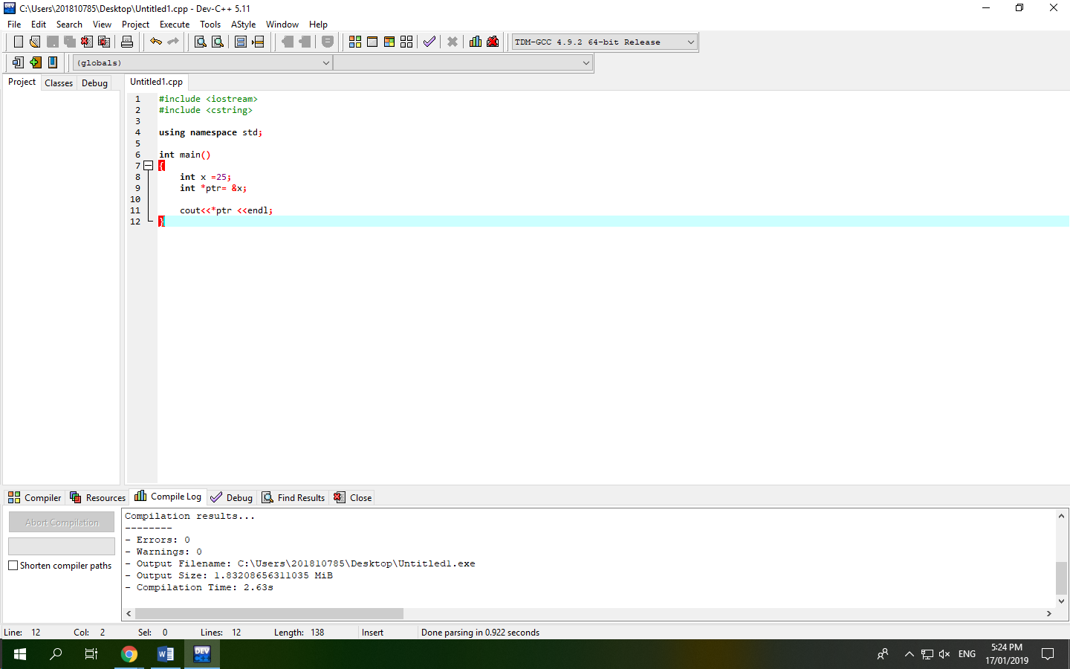

2.

#include <iostream>

#include <cstring>

using namespace std;

int main()

{

char name[]= "Domingo";

char *ptr = name;

cout<< ptr<<endl;

ptr++;

}

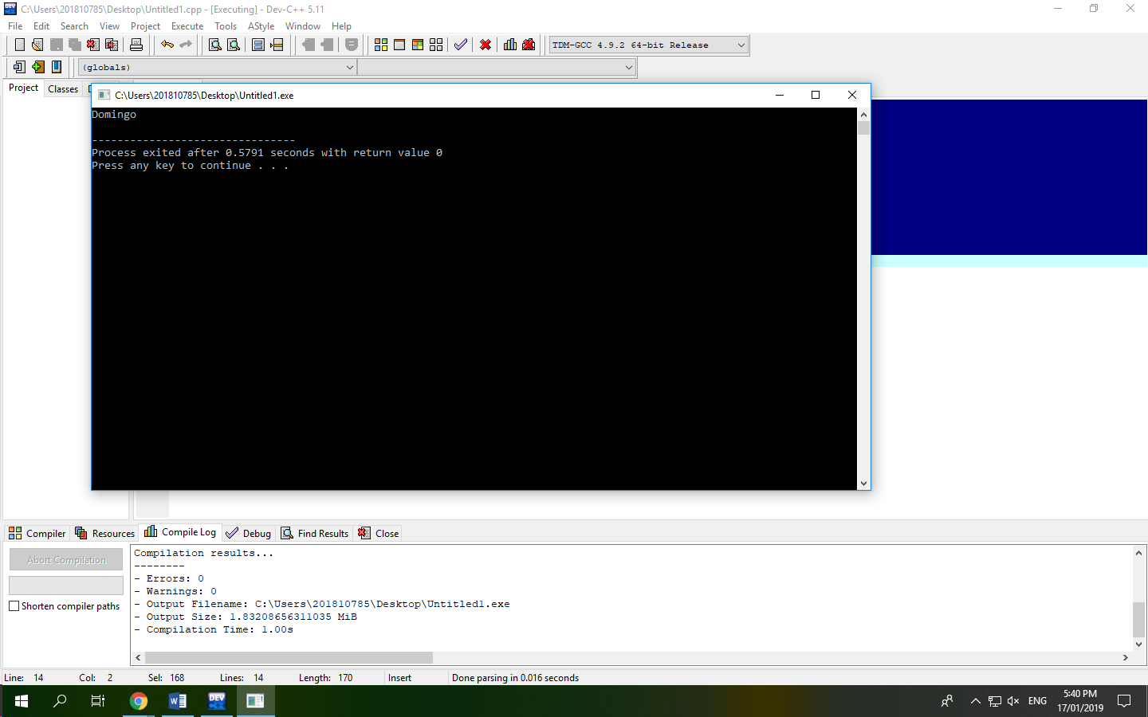

3.

#include <iostream>

using namespace std;

int main()

{

int numbers[5];

int *ptr =numbers;

cout<<"Put 5 numbers that you want:"<< endl;

cin>>numbers[0]>>numbers[1]>>numbers[2]>>numbers[3]>>numbers[4];

cout<<"Numbers you want to put"<< endl;

for(int i = 0;i < 5; i++)

{

cout<< *ptr << endl;

ptr++;

}

}

